**WORK PLANNING AND CONTROL**

Gantt **Charts** , Bar charts,Critical Path Analysis (**CPA**) or the Critical Path Method (CPM) helps you to plan all tasks that must be completed as part of a **project**. They act as the basis both for preparation of a schedule, and of resource planning.

**TYPES OF WORK PLANNING AND CONTROL METHODS**

GANTT CHART

**Gantt charts** are useful for planning and scheduling projects. They help you assess how long a project should take, determine the resources needed, and plan the order in which you'll complete tasks. They're also helpful for managing the dependencies between tasks.

Gantt charts are a visual view of tasks displayed against time. They represent critical information such as who is assigned to what, duration of tasks, and overlapping activities in a project.

A Gantt Chart, in its simplest form, is a timeline that illustrates how the project will progress during the project management process. And the timeline view offered by Gantt Charts is proven quite useful for planning and scheduling projects. It helps project managers and project teams to assess how long a project should take, determine the resources needed, understand the dependencies between tasks, and plan the order in which each task will be completed if the whole project is to deliver on time.

Bar chart

A **bar chart** is **used** when you want to show a distribution of data points or perform a comparison of metric values across different subgroups of your data. From a **bar chart**, we can see which groups are highest or most common, and how other groups compare against the others

**Bar Graph**. **Bar graphs** are **used** to compare things between different groups or to track changes over time. However, when trying to measure change over time, **bar graphs** are **best** when the changes are larger.

An **activity diagram** is one method of representing a process model. It describes the behavior of a system by depicting the sequencing of events through workflow. They illustrate what happens in workflow, what **activities** can be done in parallel and whether there are alternative paths through the workflow.

**Activity diagrams** describe parallel and conditional **activities**, use cases and system functions at a detailed level. An **activity diagram** is used to model a large **activity's** sequential work flow by focusing on action sequences and respective action initiating conditions

A process model is a formal way of representing how a business operates. An activity diagram is one method of representing a process model. It describes the behavior of a system by depicting the sequencing of events through workflow. They illustrate what happens in workflow, what activities can be done in parallel and whether there are alternative paths through the workflow.

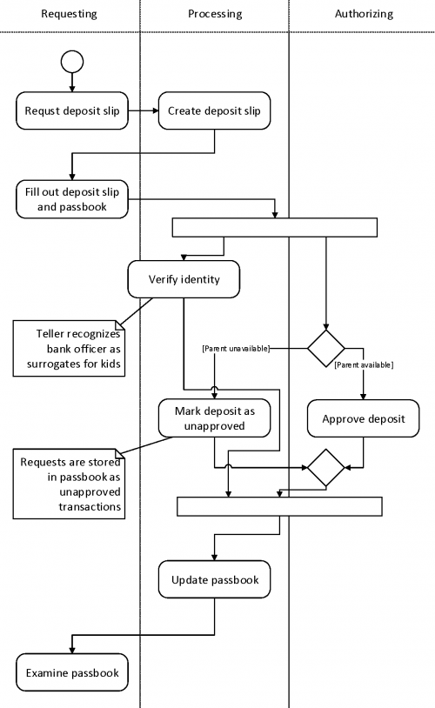

A **PERT chart** is a visual **project management** tool used to map out and track the tasks and timelines. The name **PERT** is an acronym for **Project** (or Program) Evaluation and Review Technique.

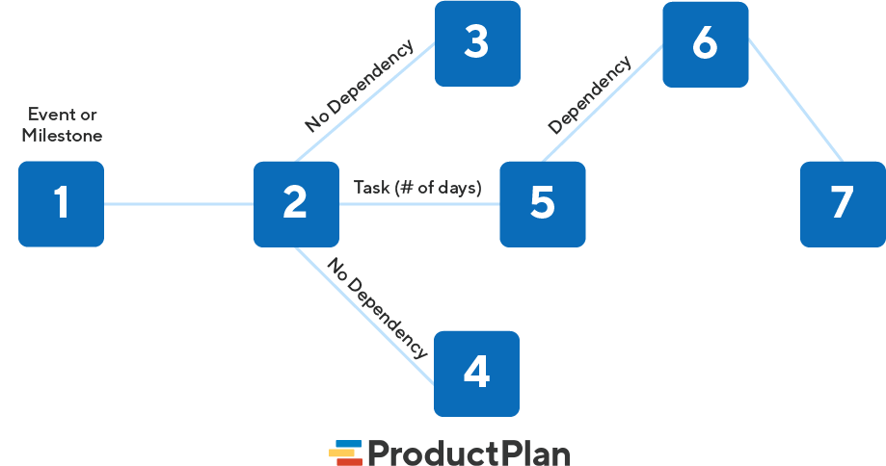

Critical path analysis (**CPA**) is a **project management** technique that requires mapping out every key task that is necessary to complete a **project**. It includes identifying the amount of time necessary to finish each activity and the dependencies of each activity on any others

* Critical path analysis is a project planning method that focuses on identifying tasks that are dependant on other tasks for their timely completion.
* Understanding the dependencies between tasks is key to setting a realistic deadline for a complex project.
* Critical path analysis is used in most industries that undertake highly complex projects.

A Gantt Chart, in its simplest form, is a timeline that illustrates how the project will progress during the project management process. And the timeline view offered by Gantt Charts is proven quite useful for planning and scheduling projects. It helps project managers and project teams to assess how long a project should take, determine the resources needed, understand the dependencies between tasks, and plan the order in which each task will be completed if the whole project is to deliver on time.

**Qualities of an effective project manager**

Regardless of the industry that you work in, if you want to be a successful project manager there are several qualities you should possess. While project management does require certain technical skills, having these soft skills can boost your success and set you apart in your workplace. The following are the eight key attributes that effective project managers share:

**1. Leadership skills**

Successful project management requires strong leadership skills on behalf of the manager overseeing the project. As a project manager, you must be able to effectively lead your team from start to finish to ensure the efficient completion of a project. Being a good leader means that you can motivate your team to perform at their best throughout the project and ensure all team members have a clear understanding of what is expected of them. You should also be able to assess your team’s strengths and weaknesses and decide how to best utilize them throughout the project completion process.

**Communication skills**

Effective project management requires clear and competent communication about the expectations, goals and responsibilities of the team who will be completing the project. Being able to efficiently communicate with your team as well as clients and management can ensure that everyone is of the same understanding regarding project expectations. Good communication skills also allow you to provide constructive feedback to your team to better guide them. Both written and oral communication skills are important for project managers to have.

**. Problem-solving skills**

Successful project managers should be able to solve a variety of problems throughout all stages of a project. Issues that may need to be solved could involve team members, clients or stakeholders related to the project. Being able to think on your feet and address disputes and problems is key to ensuring the project is completed in an efficient and timely manner.

**4. Delegation skills**

Being able to assign and oversee tasks is a fundamental component of successful project management. As the project manager, you should have the ability to access the skills of your team and sign tasks based on these skills. Effective delegation also requires you to trust your team members to fulfill their duties and allows you to avoid micromanaging them.

**5. Enthusiasm**

Enthusiasm is an important part of being a good project manager because it shows your team that you believe in the project and has confidence in your team’s ability to complete it. Being enthusiastic can also help keep team members [motivated](https://www.indeed.com/career-advice/career-development/how-to-get-motivated) and in a positive state of mind while working on their assigned tasks.

**6. Team-building skills**

Being a good team builder can help you bring a successful team together and that works as a unit to complete a project. Leading your team towards a common purpose and keeping the enthusiasm and motivation alive throughout the entire project will make you a better project manager and leader.

**7. Integrity**

Integrity, sometimes also referred to as loyalty or honesty, is an important quality for a project manager to have. Integrity can help you set a good example for your team and make them more likely to follow that example. It also shows your team that you are committed to the project and are willing to see it through to the end at all costs. Integrity additionally fosters trust from your team and promotes an ethical and responsible work environment.

**8. Competence**

Being competent in project management can promote both a sense of trust and authority in your team. Knowing how to effectively and competently lead your team is key to the overall success of project completion. However, another important part of competency is knowing when you aren’t an expert in a certain field and that the ability to ask for help when it is needed.

**PROJECT MEETINGS**

A meeting organized in the best way is a great way to get real work done. I follow this rule in my management practice when I want to plan and track my projects in an efficient manner. I know for sure that project (management) meetings play a significant role in developing team communications, leadership, and teamwork. I also confirm that project meetings let organize formal discussions and workshops designated for generating the best group decisions and solutions.

A **Project Meeting** is a regular event that involves everyone, who shares or is interested in the project, in communicating with other participants and stakeholders by discussing issues, making proposals, approving or rejecting offers, for the purpose of generating group decisions that contribute to quicker project delivery, according to the planned goals and expected results.

**TYPES OF PROJECT MEETINGS**

**Project Kickoff Meeting**

If you begin a project on the right foot, all the subsequent steps will be easier to manage. Use the following tips to organize an effective project kickoff meeting.

• **Be timely.** Aim to hold the project meeting as soon as possible within 48 hours of being assigned to the project, if possible.

• **Make time for team introductions.** Take the time to go around “the table” for introductions. This step is important even if most people know each other. Sharing your name, title, and experience with the organization is all you need.

(e.g., “I’m Jane Smith, project manager at ACME. I joined Acme in 2015 in the application development department.)

• **Share key project details.** Share the key facts that you know about the project, such as due date, budget (if appropriate), estimated team size, and some of the challenges you anticipate facing. By raising problems early, your project team will have the opportunity to start thinking about them. This is also your opportunity to inspire the team with your vision and understanding of the project’s value.

• **Emphasize the project’s purpose.** Explain the big picture reason for the project that connects to the organization’s goals. For example, this technology upgrade project will prevent system crashes in the customer service project. Therefore, this project will make a key contribution to the company’s goal of offering the best customer service in the industry. • **Provide next steps.** Provide a high-level outline of the next steps on the project, such as the next steps in the planning process and what the team can expect to hear more details.

**2. Project Status Meeting**

The purpose of status review meetings in project management is to keep a project moving toward success. Most project managers recommend using a relatively fixed agenda and time with this meeting. To keep the team engaged, systematically follow the agenda and keep the meeting held on a tight schedule. If you are using a project management software tool like Microsoft Project, consider sending a project status report in advance of the meeting to get everyone on the same page. Use these expert tips during your next status meeting:

• **Project Schedule Status:** Review the project schedule so the team can understand the impact of delays or opportunities presented by completing work ahead of schedule.

• **Project Scope Status:** Explain how much work is completed, emphasizing significant project milestones (e.g., the project is 85% complete, and our next focus is on quality assurance.)

• **Project Budget Status:** Inform the team on the project budget’s status: how much has been spent compared to the plan?

• **Issues and Risks:** Risks need to be continually assessed and discussed. During this part of the meeting, invite the team to raise problems, questions, and concerns to be managed.

• **Team Member Updates:** This agenda item gives everyone on the project team to share other thoughts and comments about the project that have not been covered elsewhere.

**3. Stakeholder Meetings**

Winning and sustaining the support of your stakeholders is an essential contributor to your project’s success. If you have many stakeholders to manage, focus this meeting on your project’s most influential stakeholders.

• **Identify appropriate stakeholders for “high touch” communication.** For example, you may focus on senior managers’ meetings from each group you need to engage. Other stakeholders can be informed using other means, such as email newsletters.

• **Present a tailored project update.** Start the meeting with a short overall project status update of five to ten minutes. These VIP updates should also speak to the individual’s examples. For instance, focus on project financials if you are meeting with a finance manager.

• **Seek and listen to feedback.** Some stakeholders will make their opinions heard without prompting, while some prefer to be quietly engaged. The stakeholder meeting is your opportunity to engage with stakeholders fully.

**4. Change Control Meetings**

Despite the best planning in the world, you will encounter surprises on your projects. A risk event may occur like a system failure, vendor delay, or something else. These changes need to be managed in a disciplined, systematic way. While you may have the power to approve small change requests as the project manager, most change requests will need to be reviewed through a governance process and meetings.

• **Provide an agenda.** Provide a plan in advance so that attendees know which changes will be discussed. The best practice is to circulate the agenda at least • one business day in advance of the meeting date (along with supporting documents like copies of the change requests).

• **Discuss change assessment.** For each proposed change request, present your professional opinion on the change’s impact on the project.

• **Make a change recommendation.** Request the project sponsor approve, deny or comment on the change request.

• **Plan next steps.** Explain how the change request decision will be communicated and outline how you will describe the project’s impact.

**5. End Project Meetings**

The end of the project (or the project phase) is an excellent opportunity to review how the work unfolded. For the best results, schedule this meeting with the project team members within a few days of the project’s completion.

• **Set ground rules.** At the end of a project, the team may be worn out from working long hours on the project. Before the meeting starts, explain your expectations and the purpose of effective project meetings. For example, encourage project team members to avoid playing the blame game.

• **Review lessons learned and what you should keep doing.** Ask yourself, “*What activities and methods on the project added value?*” For example, it could be that the project team responded to all change requests within two business days.

• **Review lessons learned and areas of improvement.** What can you and the project team do differently on future projects? Encourage everyone to look for ideas that can be generalized and used by others in the organization.

• **Don’t forget to celebrate.** Take the time to celebrate the project’s success! If budget permits, take the project team out for lunch or send a virtual gift card.

**PROJECT CLOSURE**

The close of the project is the final phase of your job, it’s the last turn of the [project life cycle,](https://www.projectmanager.com/project-management#section3) and like any other aspect of a project, it requires a process. The following are five steps you should take to make sure you’ve dotted all the I’s and crossed all the T’s, as well as taken full advantage of the experience.

The project closure phase is a process in itself. You need to get the sign-offs on deliverables, disband the team, closeout contracts, and archive the documentation for future reference.

**1. Arrange a Post Mortem**

Managing a project isn’t only about [tasks](https://www.projectmanager.com/task-lists) and [resources,](https://www.projectmanager.com/resource-management) budget and deadlines, it’s an experience you can constantly learn from. While you should have been learning throughout the project, now is a great time to look back without the pressure and distractions that might have dulled your focus.

Gather the core team to invite feedback about what worked, and what didn’t. Encourage honesty. By documenting the mistakes and the successes of the project, you’re building a catalog that offers historic data. You can go back and look over the information for precedents when [planning for new projects](https://projectmanager.com/planning).

Projects are never standalone things, but part of a continuum, where the specifics might vary, but the general methods usually remain the same. There’s a wealth of knowledge produced after any project closes.

**2. Complete Paperwork**

As noted, projects generate reams of documents. These documents are going to have to get sign off and approval from [stakeholders](https://www.projectmanager.com/stakeholder-management). Everything needs attention, and must be signed for, which is the legal proof that in fact these documents have concluded. That includes closing all contracts you might have made with internal partners or [vendors](https://projectmanager.com/blog/vendor-management) or any other resources you contracted with.

This includes addressing all outstanding payments. You want to make sure that all invoices, commissions, fees, bonus, what have you, are paid. Complete all the costs involved with the project. It’s not done, if it’s not paid for.

**3. Release Resources**

You assemble a team for the project, and now you must cut them loose. It’s a formal process, and a crucial one, which frees them for the next project. Each team is brought together for the mix of skills and experience they bring to a project. The project determines the team members you’ll want to work with, and each project is going to be a little bit different, which will be reflected in the team hired to execute it.

This is true for internal as well as external resources. The external ones might be more obvious, as you contracted with them, and that contract is going to have a duration. When it’s over, make sure they’re all paid in full so they can sign off and leave. But internal resources remain, so you have to remind yourself that their time on the project is also limited, and you might be blocking other team’s projects if you don’t release your resources once the project is done.

**4. Archive Documents**

There are [lessons to be learned](https://www.projectmanager.com/templates/lessons-learned-template) from old projects, which is why you meet with your team regularly during the project and look back on the process afterwards. However, if you don’t have an archive in which to pull the old records, then whatever knowledge you gain is lost because of poor organization and management. You worked hard to have great project documentation, don’t lose it.

Before you close a project, archive all the documents and any notes and data that could prove useful. Even if you never access it, there’s a need to keep a paper trail of the work done on any project for other people in the organization. This might include legal teams, or HR teams, or even your successor. You never know when someone might have to go back and respond to a question or want to learn how an old issue was resolved. Consider it like putting away provisions for the winter.

**5. Celebrate Success**

If it sounds silly to you, then you’re not doing your job. There’s nothing silly about [rewarding your team](https://projectmanager.com/team-management) to acknowledge a job well done. It creates closure, which is what this part of the project is all about, but it also plants a seed that will bloom in later projects when you work with members of the old team.

That’s because when you note a job well done you’re building morale. It makes team members feel better. You might have been a hard task master in the project, but you give them their due for a job well done. That creates loyalty, and they’re going to work even harder for you the next time. And there will be a next time, because a happy team is a team that you retain. Why would you want to close a project and lose the very resources that made it a success? Loosen up!

**Project Closure Checklist**

To make sure that every i is dotted and t crossed, follow this step-by-step project closure checklist.

1. Start at the beginning with the [project scope document](https://www.projectmanager.com/training/write-scope-work) you created and make sure that you’ve meet all the requirements listed there.
2. Make sure that all deliverables have been handed off and signed by stakeholders, getting their approval and satisfaction.
3. Other project documents must also be signed by the appropriate person, this includes any outstanding contracts and agreements with vendors and other contractors.
4. Once documents are signed off on, then process them and pay off all invoices and close out any project-related contracts.
5. Add all documents together, including finalizing all project reports, then organize and archive them as historical data to be used for future reference.
6. Use collected paperwork to identify and document the lessons learned over the course of the project, including any feedback from stakeholders, so you don’t make the same mistakes in future projects.
7. Assign a transition support person to shepherd the project after completion, so that the project closure is thorough.
8. Release or reassign the project resources, which includes your team and other project personnel and any equipment or site rentals used for the project.
9. If you’ve not used a [project management software](https://www.projectmanager.com/software), get one, as it helps control not only the life cycle of the project, but also the process of closing the project thoroughly.
10. Finally, but perhaps most importantly, celebrate with your project team. They did the work and deserve credit and an opportunity to blow off steam until the next project is started.

**Importance of feedback**

The feedback loop is an integral part of building and maintaining that alignment from a project’s inception through its completion. Unfortunately, teams are often so busy with project tasks that soliciting and evaluating feedback become lower priorities. If that sounds familiar, consider these four big reasons [stakeholder](https://pm-alliance.com/project-stakeholder-expectations/) feedback is important to your team.

**Feedback is important because it provides the recipient with an opportunity to learn how the project manager (someone other than his immediate functional manager) perceives his work performance, which is often too specialized for the functional manager to provide constructive feedback**

1. Clear and honest communication in the team and during a project helps your employees avoid major mistakes. Feedback saves you the time of correcting someone’s work, or the regrets of a worker who feels like he failed.
2. You also form better relationships with the people in your team. Feedback often involves criticism, which is something most people aren’t comfortable with. But when given in the right way, it can help them evolve.
3. A friendly approach works well here. You can not only help others see what they might be doing wrong, but allow them to use this as a piece of advice, not judgment. Make them feel like you believe in them and just want to help them reach the project’s goal sooner. That will make them even more motivated to do a good job. Constructive feedback can serve as a tool to motivate employees and [boost performance](https://www.actitime.com/productivity/workplace-productivity).
4. It promotes personal and professional growth. Feedback is about listening actively, taking the time to analyze, and then thinking of the best possible solution to perform better. It provides positive criticism and allows to see what everyone can change to improve their focus and results. It brings people together and creates a healthy communication flow.
5. Creating a friendly work environment where everyone’s open to criticism and even seek feedback themselves (both from you and from their teammates) saves you big time. Often the best ideas can come from someone on the team who simply mentioned a solution to a problem or pointed out an issue that others hadn’t noticed yet.
6. Last but not least, there are the direct benefits of feedback related to business growth, such as saving money, making more sales, and completing a project on time.

All this makes people on the team more engaged in the work process. You might notice they show more respect and loyalty once giving feedback becomes a regular practice.

**7.Feedback is critical for ongoing improvement**

The best way to find out where you need to improve is to ask your stakeholders to tell you what isn’t working. If a sponsor reports that your team coordinator is slow to respond to questions, you’ll know there are communication issues that need to be addressed. When end users tell you they only received an hour’s notice before their work area was impacted by project activities, you can put measures in place to send out alerts earlier in the process. Future projects will benefit from the lessons you learn today and your stakeholders will have greater confidence that your team has the expertise to skillfully execute any complex or high-visibility projects that may be on the horizon.